**10-12-23 notes**

Plotting with Pandas

Goals:

By the end of this lesson, you will be able to:

* Create plots by using the DataFrame.plot() method.
* Summarize the advantages and disadvantages of creating charts by using the DataFrame.plot() method.
* Use Pandas to analyze a complex dataset and chart the corresponding visualizations.

5:45-6:08pm- PyCitySchools walkthrough.

Carson- **Squirrel beer**

**Instructor Average Rainfall solution:**

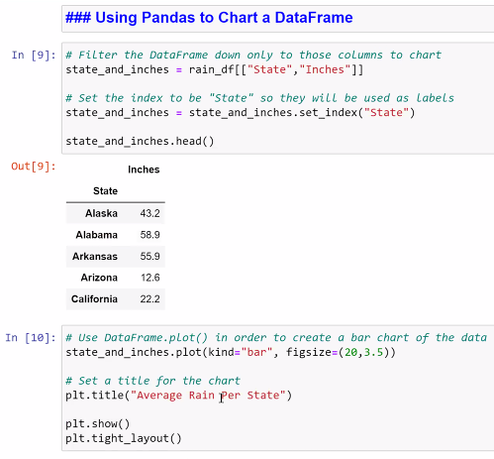

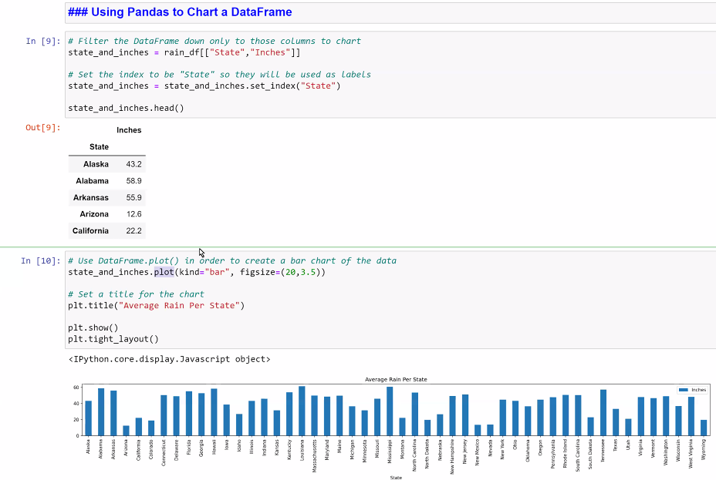

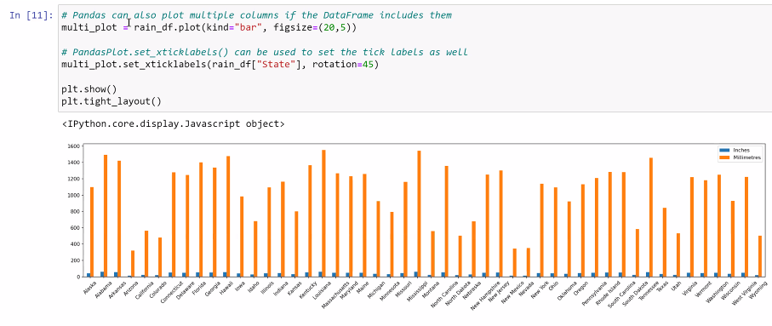

**Settlements Solution:**

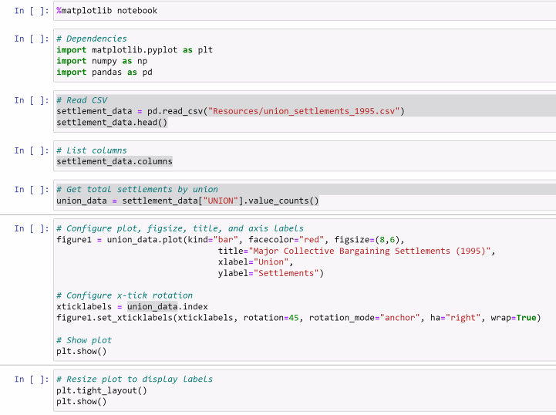

**Unemployment chart solution:**

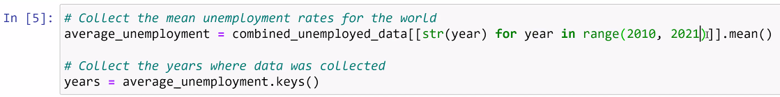

^Apply the year to the combined table, like a filter, and calculate the average for each year

**Traveling Companions Solution (Merge-a-thon):**

**Part 1:**

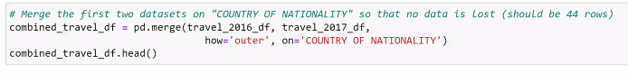

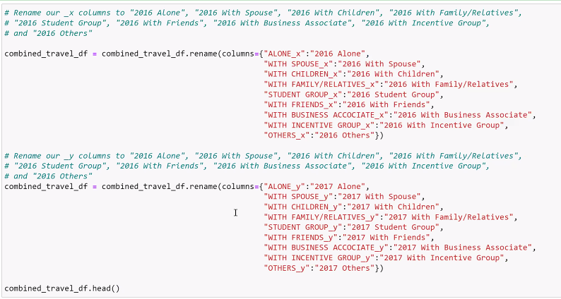

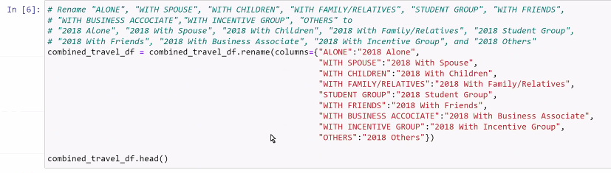

^ ACCOCIATE is spelled with 2 Cs in the original column names. It caught me up for a moment, thought i'd share so no one else has to finagle it

**Part 2:**



^.select_dtypes says to select only records with numbers (int or float). Convert to numpy.number, then you can run mathematical operations on it.

